**Requirement**

**Relevance to Sustainable Development Goals**

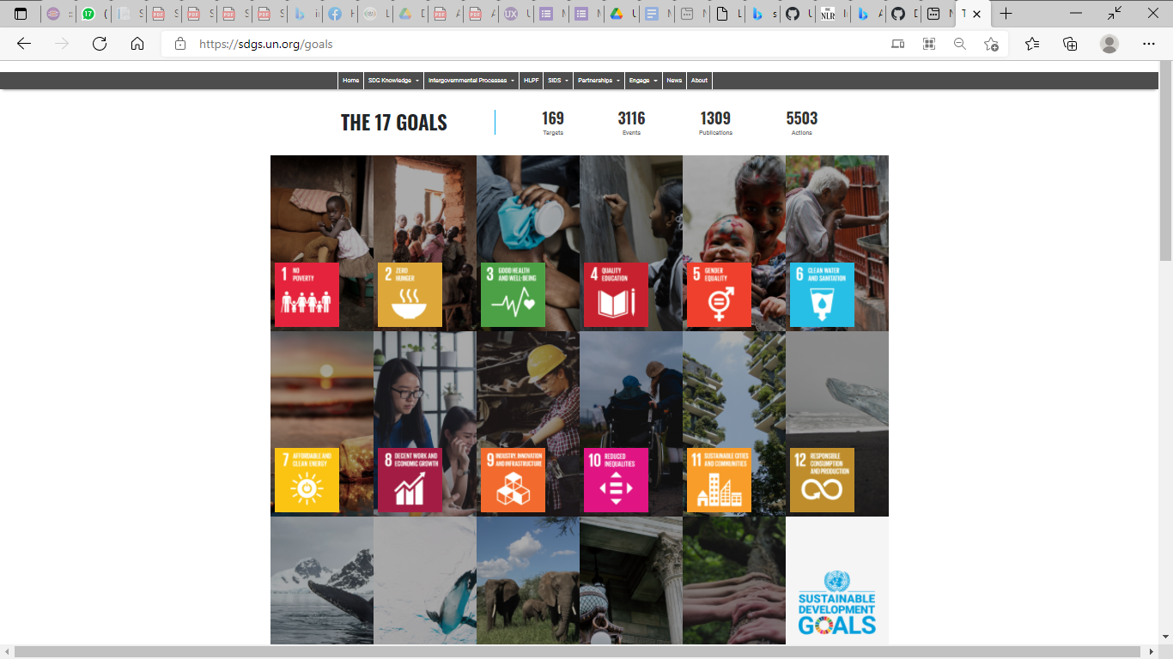

Source - <https://sdgs.un.org/goals>

**Approach taken for development of DiCRA**

The objective of the DiCRA platform is to provide free and open access to geospatial datasets through a geospatial digital platform thereby enabling concrete evidence-driven policies and concerted action from all stakeholders involved in sustainable and climate resilient agriculture. Through geospatial analysis and data powered positive deviance approaches, the platform informs stakeholders in food systems, on which farms are more resilient to extreme weather events. Indigenous knowledge is tapped through field validation and ethnography to suggest good practices on climate resilient farming that are already working well through bottom-up approaches, to feed into large scale agriculture programs and policies and optimize public investments on climate resilient agriculture.

DiCRA platform contributes to 2 SDG goals namely: Goal 2 to End hunger, achieve food security and improved nutrition and promote sustainable agriculture and Goal 13 to take urgent action to combat climate change and its impacts. The specific targets and indicators that the platform contributes are shown in the table below:

|  |  |  |
| --- | --- | --- |
| SDG Goal | SDG Target | SDG Indicator |
| 2. End hunger, achieve food security and improved nutrition and promote sustainable agriculture | 2.4: By 2030, ensure sustainable food production systems and implement resilient agricultural practices that increase productivity and production, that help maintain ecosystems, that strengthen capacity for adaptation to climate change, extreme weather, drought, flooding and other disasters and that progressively improve land and soil quality | 2.4.1 Proportion of Net Sown Area to Cultivable Land |
| 2. End hunger, achieve food security and improved nutrition and promote sustainable agriculture | 2.4: By 2030, ensure sustainable food production systems and implement resilient agricultural practices that increase productivity and production, that help maintain ecosystems, that strengthen capacity for adaptation to climate change, extreme weather, drought, flooding and other disasters and that progressively improve land and soil quality | 2.4.3: Percentage of net area under organic farming. |
| 2. End hunger, achieve food security and improved nutrition and promote sustainable agriculture | 2.5: By 2020, maintain the genetic diversity of seeds, cultivated plants and farmed and domesticated animals and their related wild species, including through soundly managed and diversified seed and plant banks at the national, regional and international levels, and promote access to and fair and equitable sharing of benefits arising from the utilization of genetic resources and associated traditional knowledge, as internationally agreed | 2.5.2 Conservation of germplasm |
| 13. Take urgent action to combat climate change and its impacts | 13.1: Strengthen resilience and adaptive capacity to climate-related hazards and natural disasters in all countries | 13.1.1 Number of States with strategies for enhancing adaptive capacity and dealing with climate extreme weather events |
| 13. Take urgent action to combat climate change and its impacts | 13.2: Integrate climate change measures into national policies, strategies and planning | 13.2.1 Pre 2020 action achievements of pre 2020 Goals as per country priority, percentage reduction in emission intensity of GDP, over 2005 level by 2020 |